**Data Structures Lab Report 11**

Group Members: Vivek Kunapareddy, Yuang Chen

**Discussion of Objectives/Concepts:**

The objectives explored in this assignment were the implementing and working of graphs. This is extremely useful in software engineering as this is a data structure which is widely used in general software design.

**Screenshots:**

Add edge:

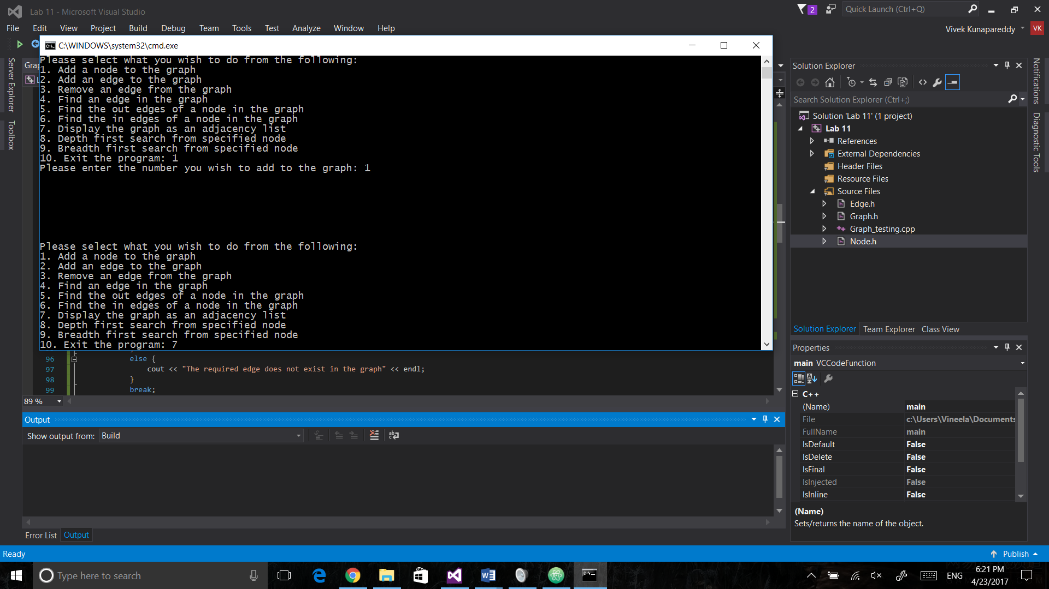

Display graph:

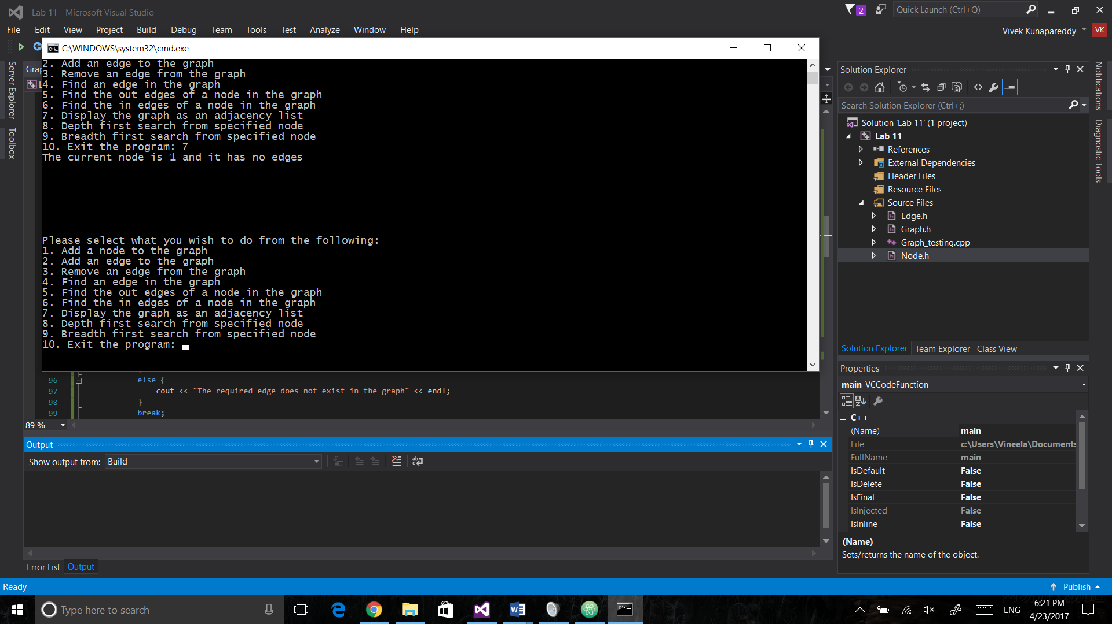

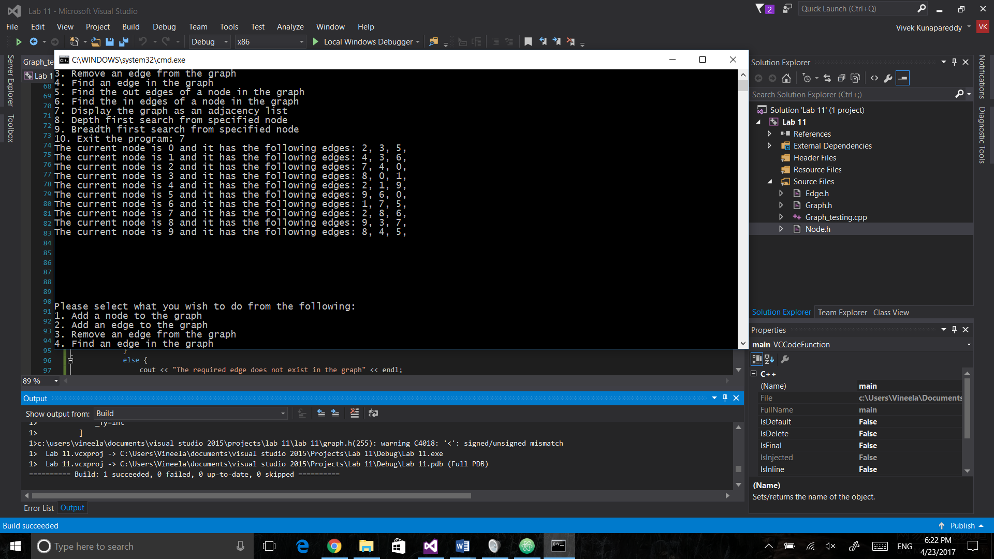

Depth first search:

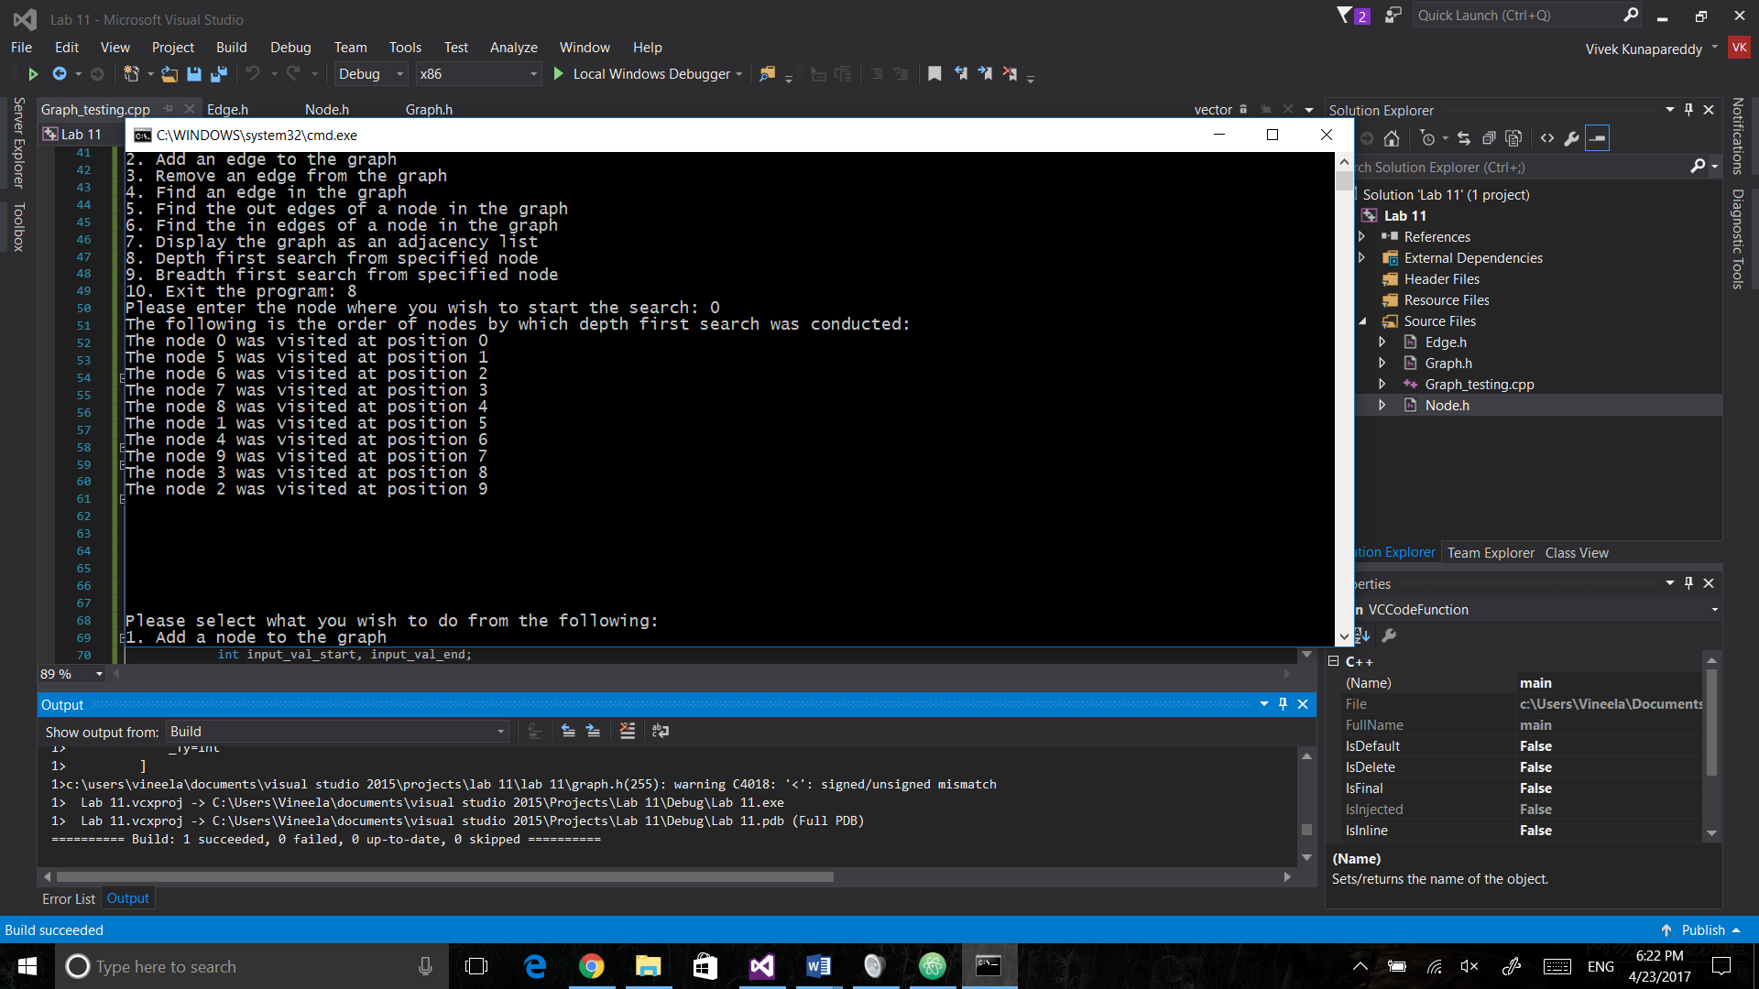

Breadth first search:

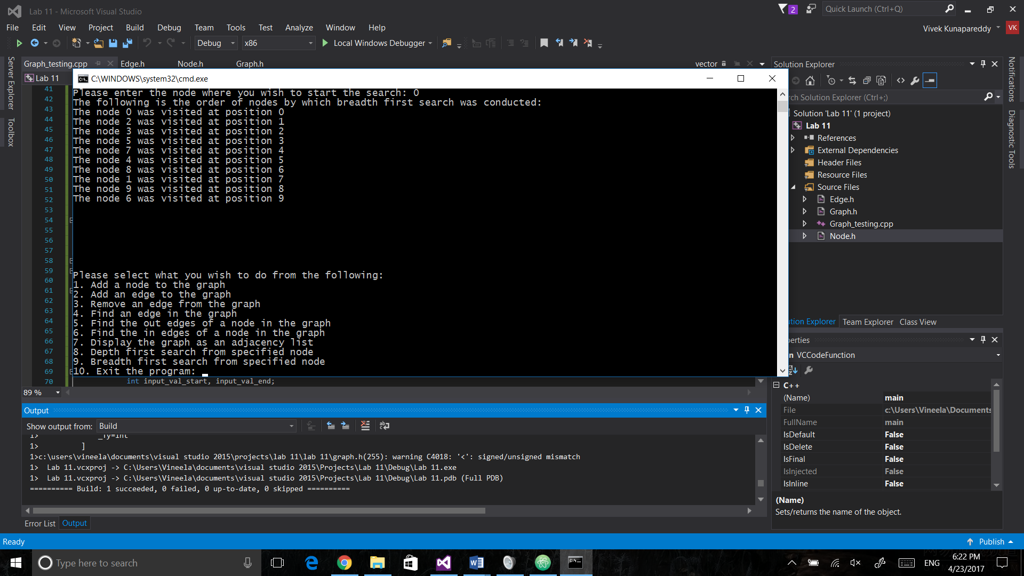

**Discussion of BFS/DFS:**

The depth first search was implemented using a stack. This is because the initial neighbor which is explored needs to be explored first. Hence using stack which is last in, first out accomplishes this.

For Breadth first search, the underlying data structure used was a queue. Since all the neighbours need to be explored first before diving deeper. Hence a queue which uses the principle of first in, first out would be perfect to emulate this.

Applications:

Breadth first search is probably useful when finding the shortest distance between two nodes as it looks for neighbours first

Depth first search is probably useful when solving mazes or something along those lines as it dives deep and looks for a node

Memory consumption:

Since the current implementations are iterative, both use the same amount of memore, which is in terms of O(N)

Choice of BFS/DFS:

The choice of which sort of search to use generally depends on what the structure is trying to accomplish. As stated above, depending on the applications, the specified search should be chosen.

**Group Contributions:**

The Graph and main design was done by Vivek